1. How to create Ubuntu instance in AWS.

* Open instances page in AWS console

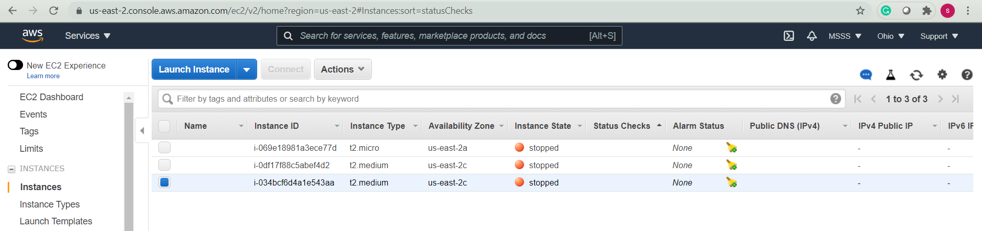

* Click on launch instance

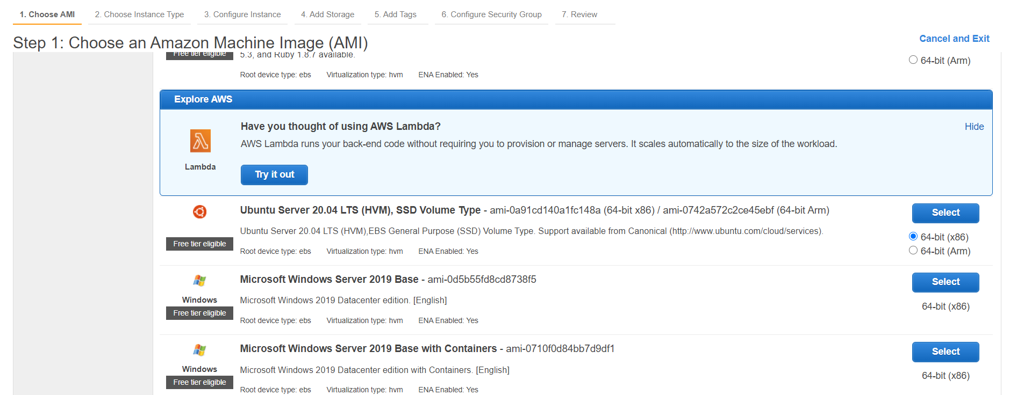

* Choose Ubuntu instance 64-bit
* For docker we need at least 4 GB RAM.

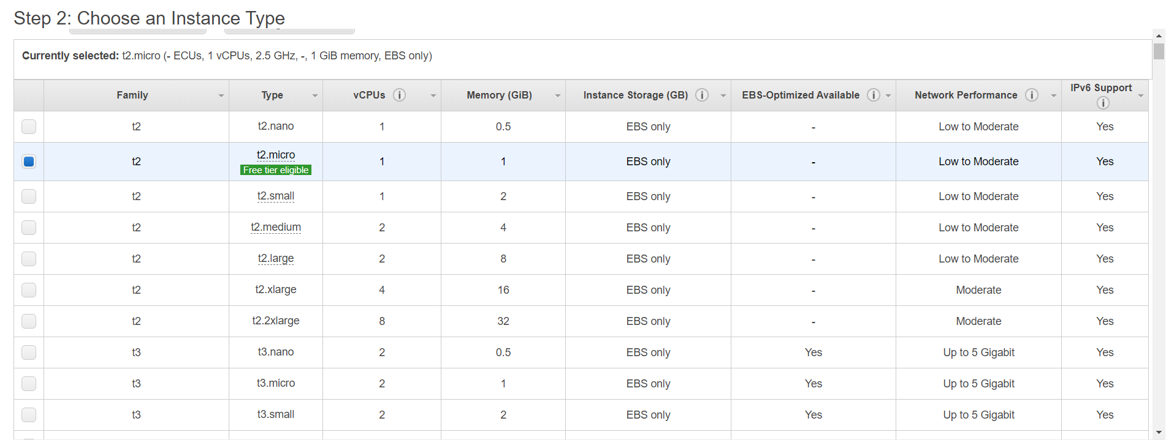

* Choose t2.medium from the instance type.
* In add storage change storage to 15 GB.

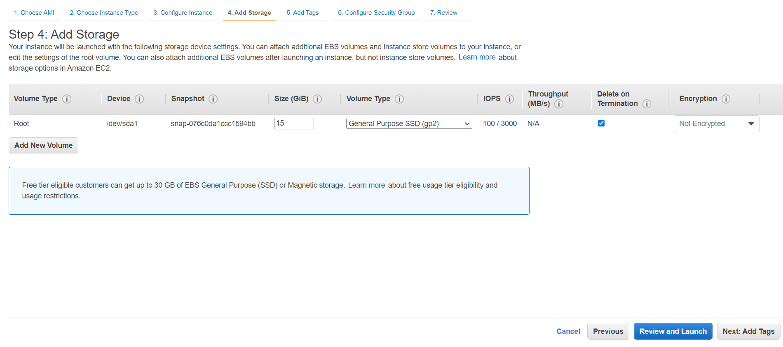

* In the configure security groups we need to change security group of our own choice(any name is fine).
* Change the type to all traffic.
* Change the source to any where.

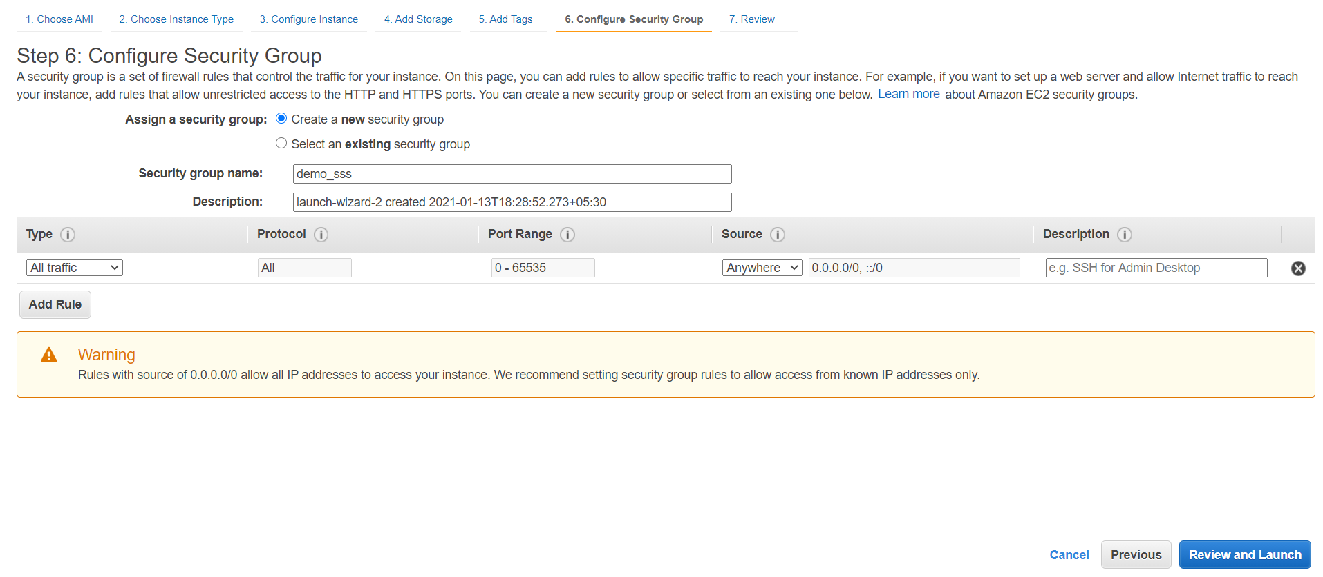

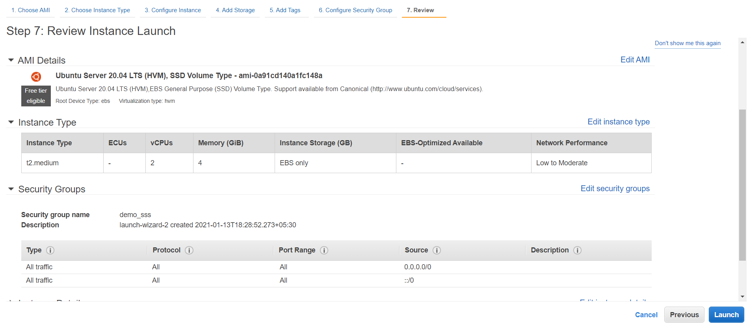

* Review all the things before launching.
* Create new private key or select from the given.

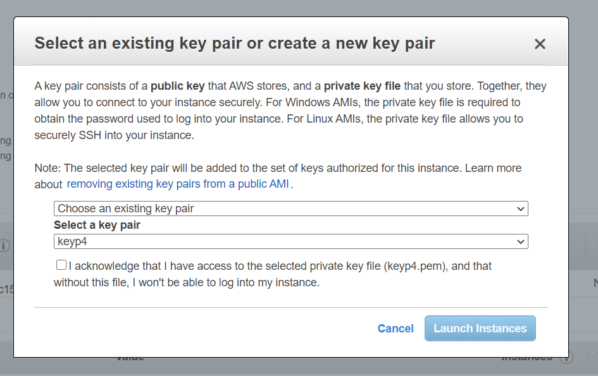

* Start the instance.

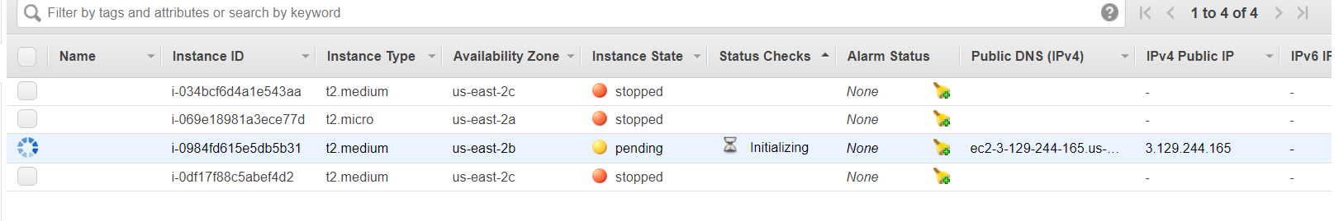

* Copy public ip form the console.
* Open mobaxterm and create a new session.

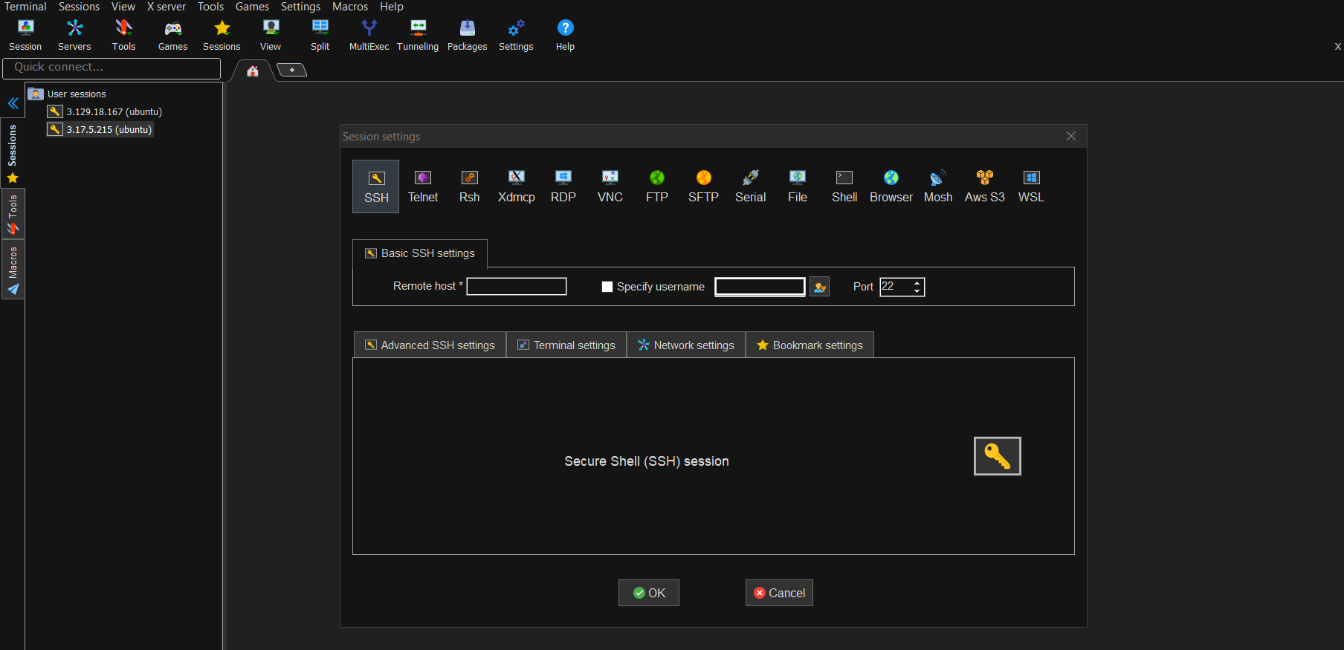

* Use SSH and copy the public ip in the place of remote host.
* Specify username as Ubuntu.
* In advanced settings select use private key option and paste the path link of the pem file.

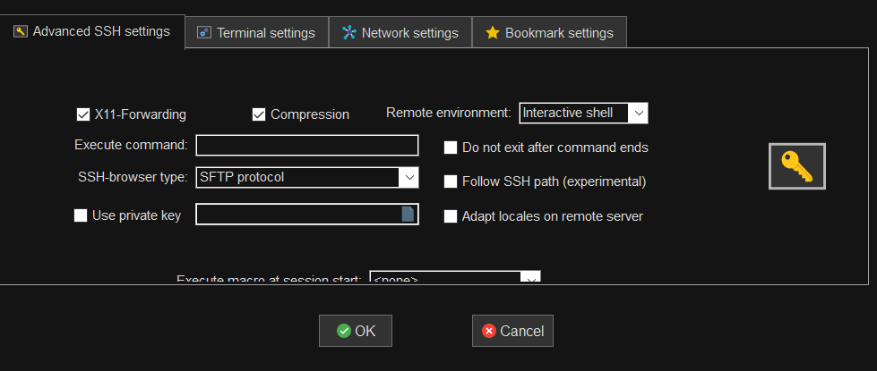

* After the instance starts it will be like this.

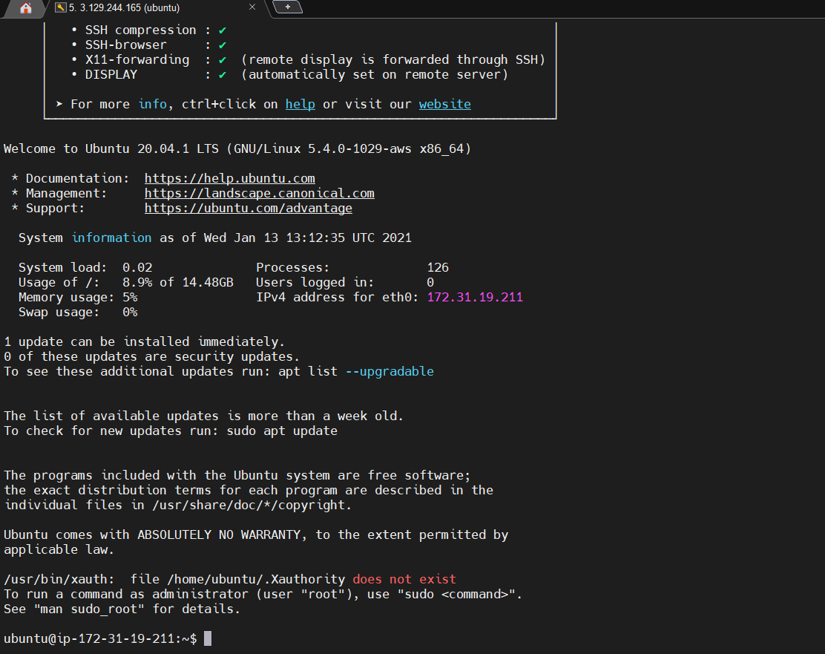

1. Install docker and Jenkins on the instance. (https://docs.docker.com/engine/install/ubuntu/)

* Type sudo su -

to change into the root directory.



* Type apt update to update the packages in the instance.

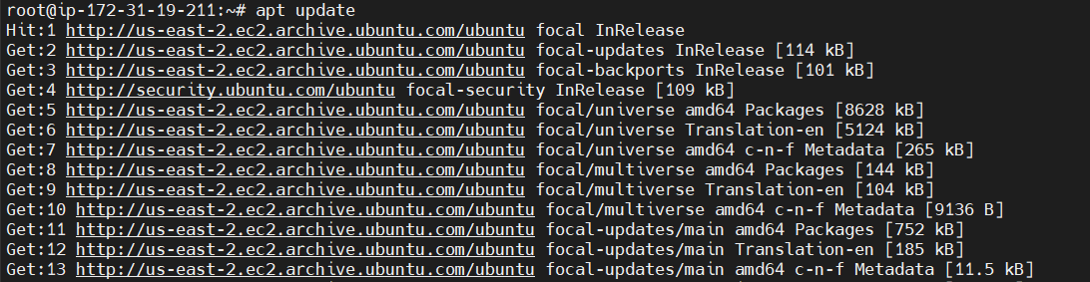

* Type sudo apt-get install \

apt-transport-https \

ca-certificates \

curl \

gnupg-agent \

software-properties-common

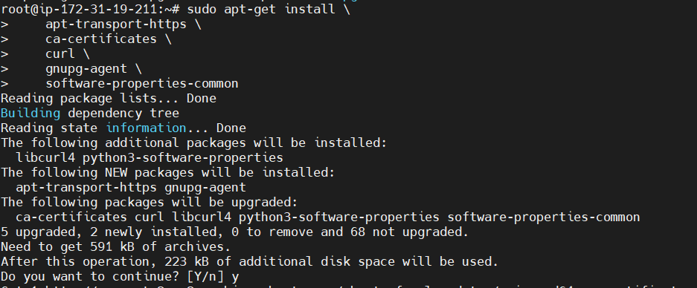

* Type curl -fsSL https://download.docker.com/linux/ubuntu/gpg | sudo apt-key add -



* Type sudo apt-key fingerprint 0EBFCD88

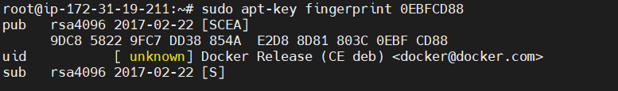

* Type sudo add-apt-repository \

"deb [arch=amd64] https://download.docker.com/linux/ubuntu \

$(lsb_release -cs) \

stable"

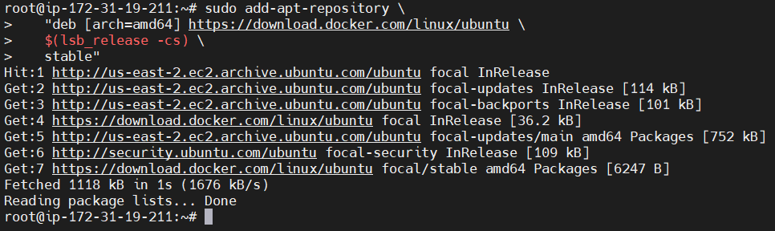

* Type sudo apt-get update

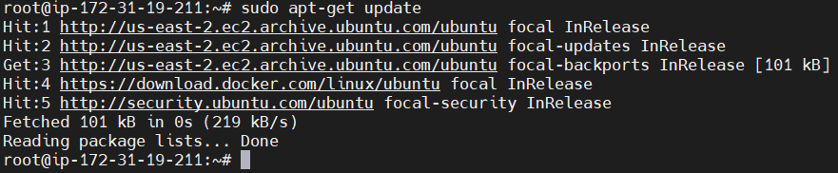

* Type sudo apt-get install docker-ce docker-ce-cli containerd.io

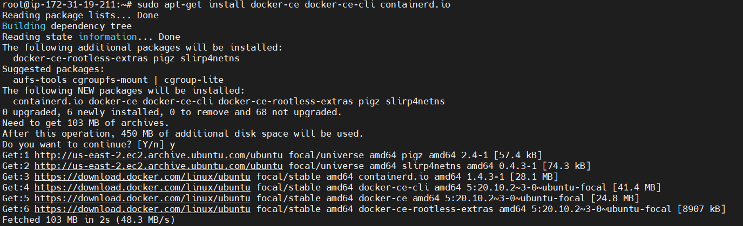

* Type docker version to identify the version of installed docker

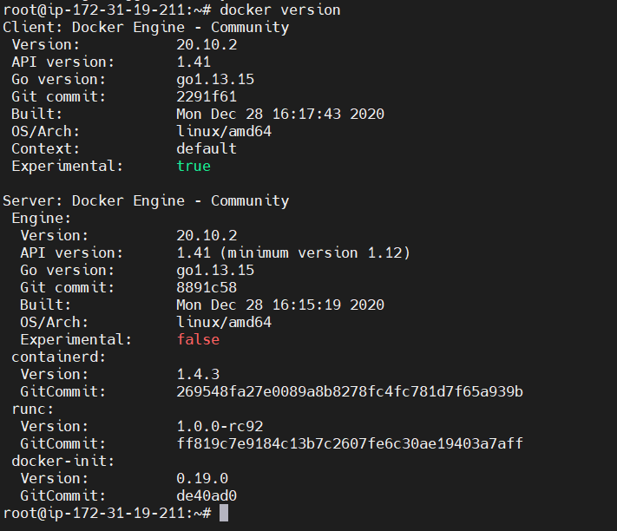

* Move out to ubuntu instance to register ubuntu as an user for docker.

sudo su - ubuntu

* To register ubuntu as an user type command sudo usermod -aG docker $USER && newgrp docker



* Now type docker version command to check whether is is working or not.
* Type docker system info to know system information.

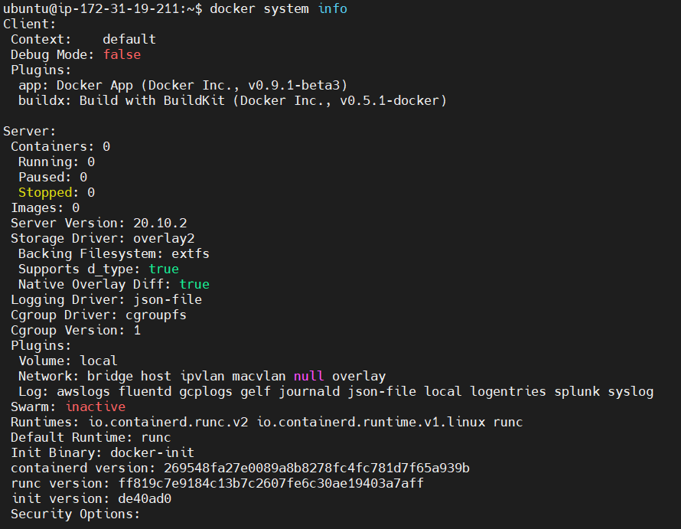

* Type docker ps -a command to know how many containers are created/present.



* Type docker run hello-world to know whether docker is running fine or not.

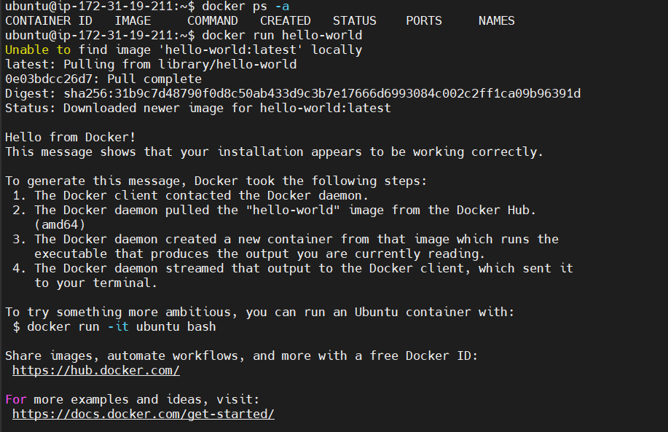

1. How to install jenkins on docker and start it

* Type docker volume create jenkinsvol to create jenkins.

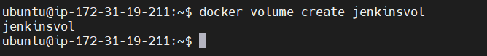

* Type docker run -u root -d --name myjenkins_server -p 9080:8080 -p 9096:9096 -v jenkinsvol:/var/Jenkins_home/workspace jenkins/jenkins:lts to create jenkins port.

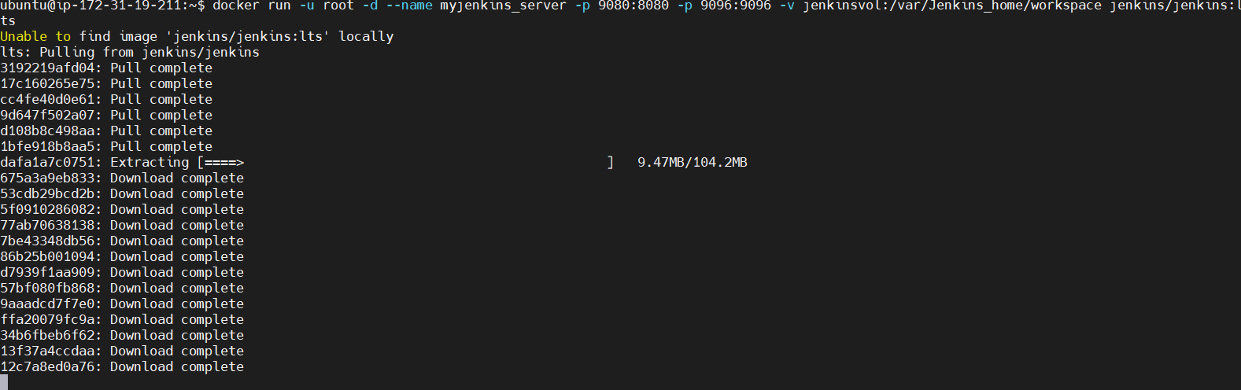

* Type docker images command to observe the total images present on the system.

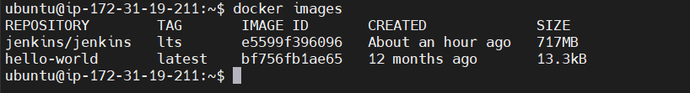

* Type curl ipconfig.io command to know ip address and add :9080 to the url



* You will get a web page like below

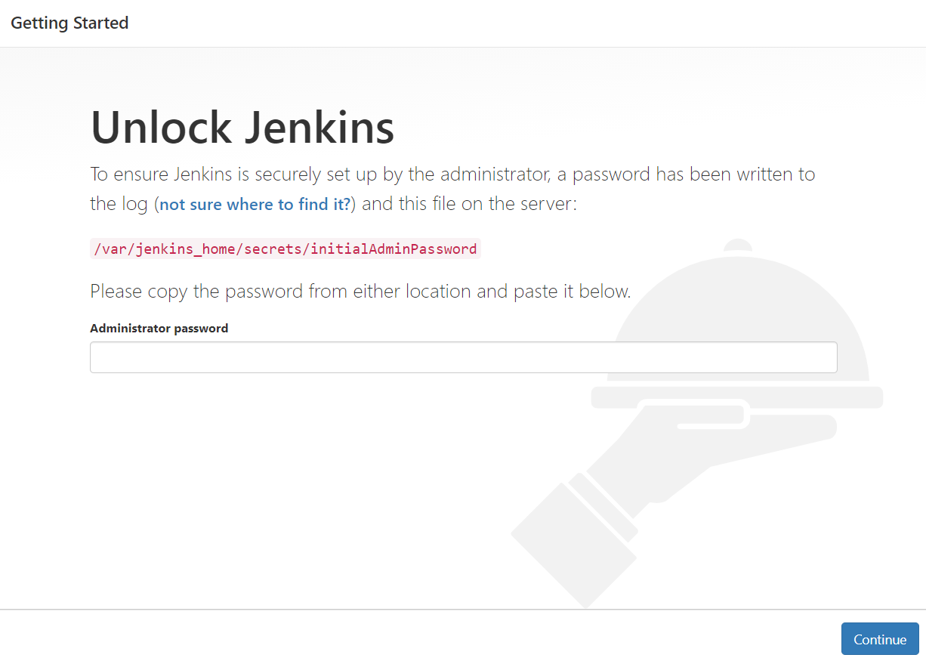

* You need to switch to the container myjenkins_server to find the password using below command docker exec -it myjenkins_server /bin/bash



* Now type cat /var/jenkins_home/secrets/initialAdminPassword
* You will find a password



* Type the password in web page and install suggested plugins.
* Now you can use jenkins and it doesnot require jdk since it was installed in docker.
* After installing jenkins will be like this

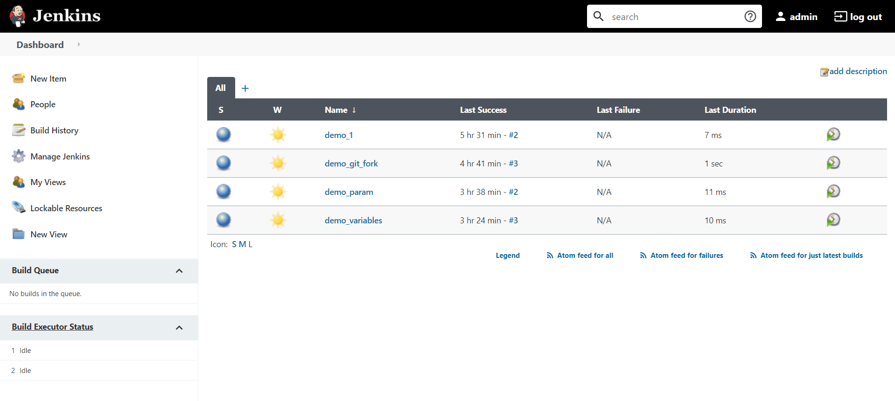

1. How to open jenkins after booting up our instance freshly.

* docker version
* docker start myjenkins_server
* docker ps
* curl ipconfig.io
* Then using the ip open jenkins.

Assignment:

1. Create Freestyle Job in Jenkins to print Env variables (10 env variables)

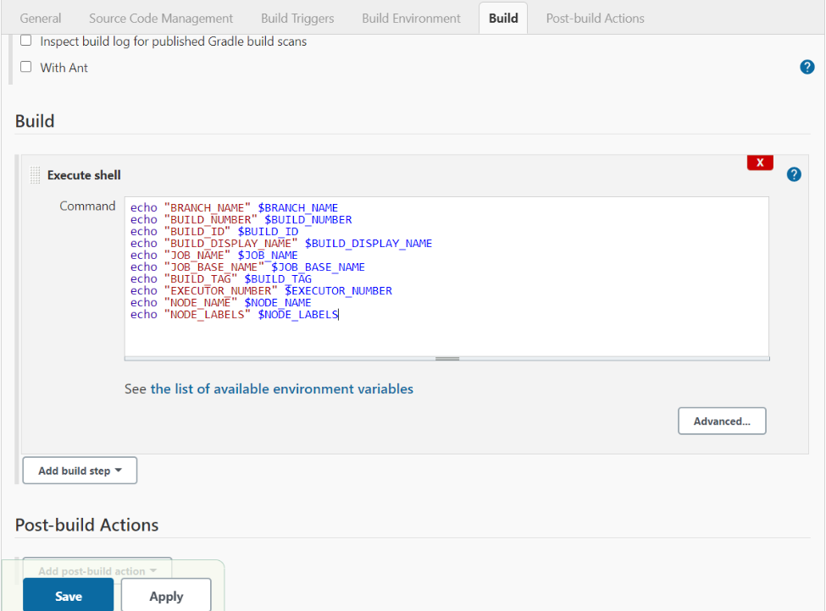

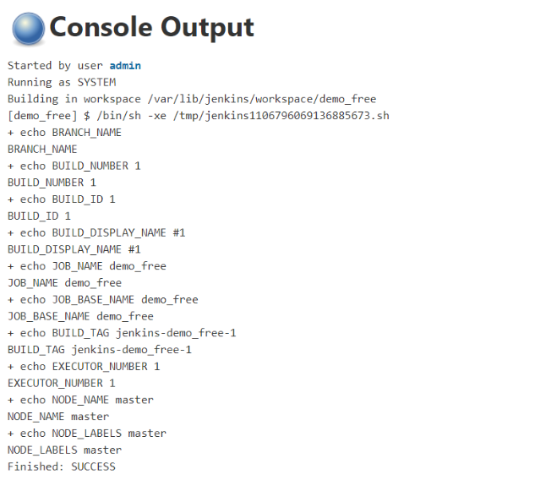

1. Create a Parameterized Job (Free Style) i.e. One string / boolean / Choice and display the values

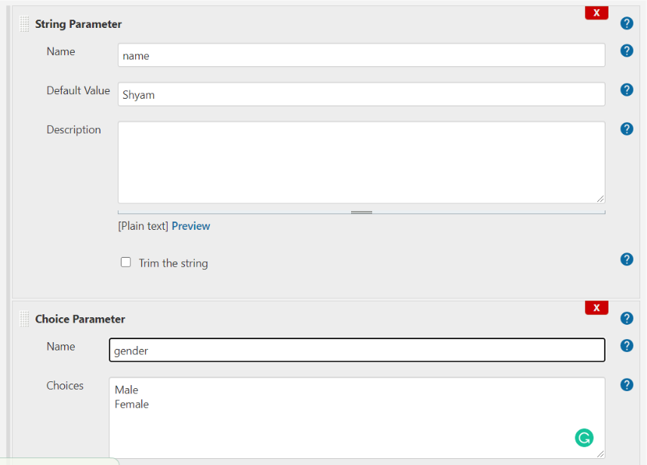

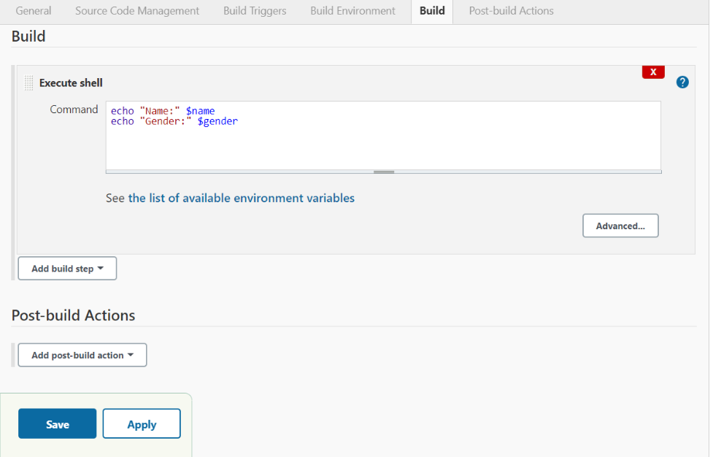

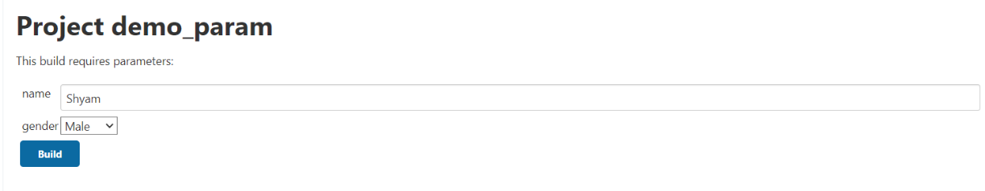

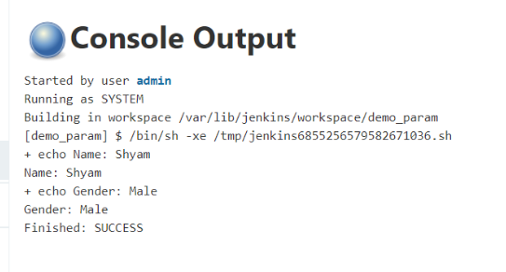

1. Create Freestyle Job in Jenkins to print Env variables (10 env variables) and schedule this for every 15 mins

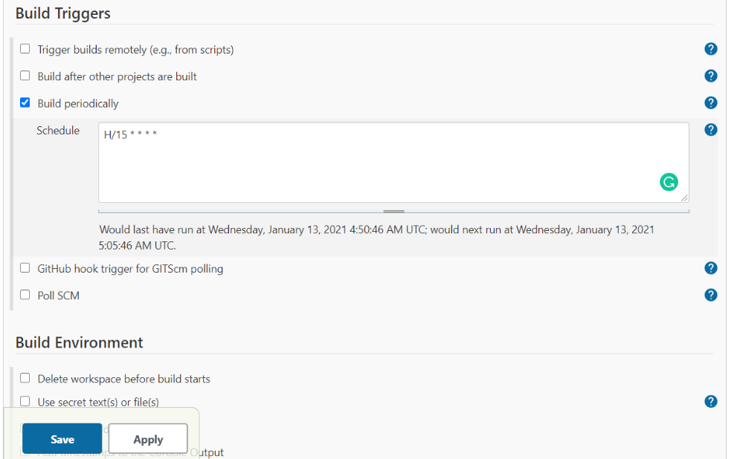

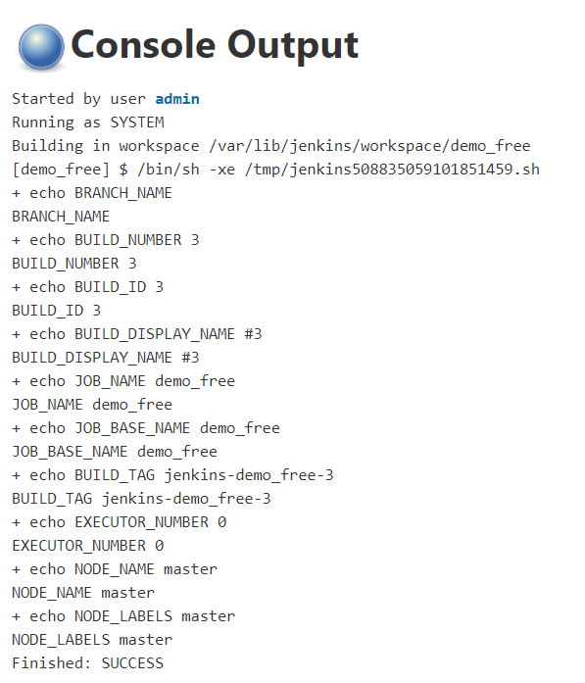

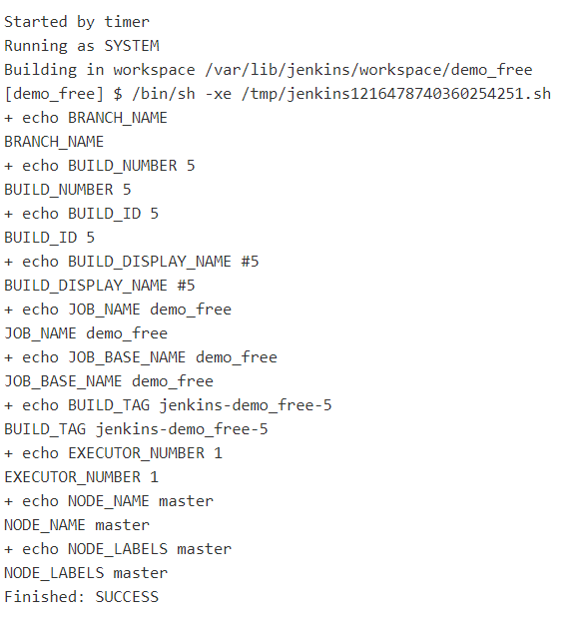

1. Fork this repository and build https://github.com/anjuna661/git2

* First fork the repository
* Add the source code from Git and then add the git url in the configure project
* Build the project

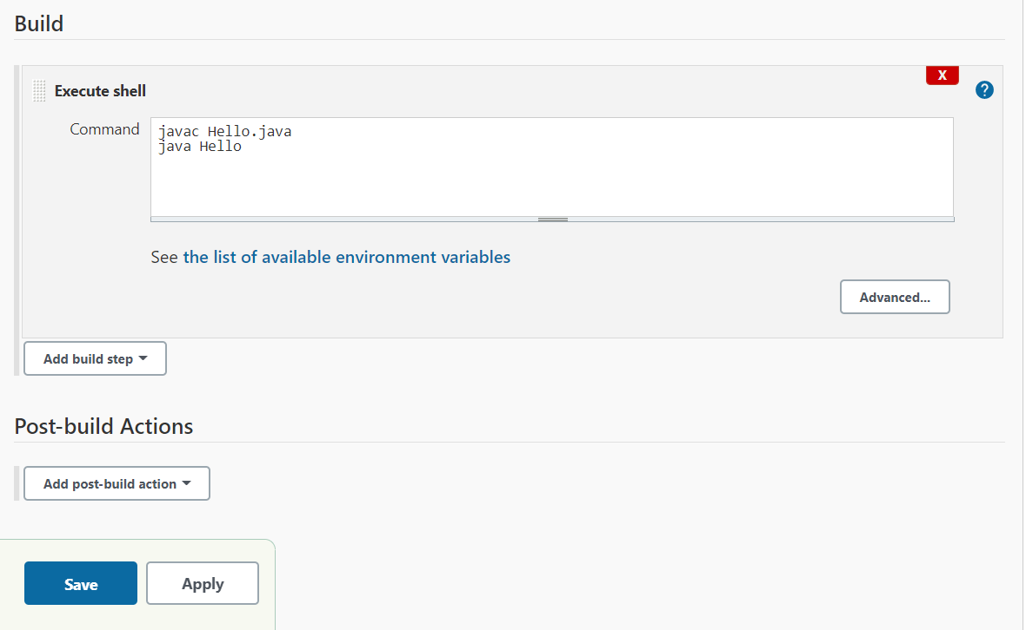

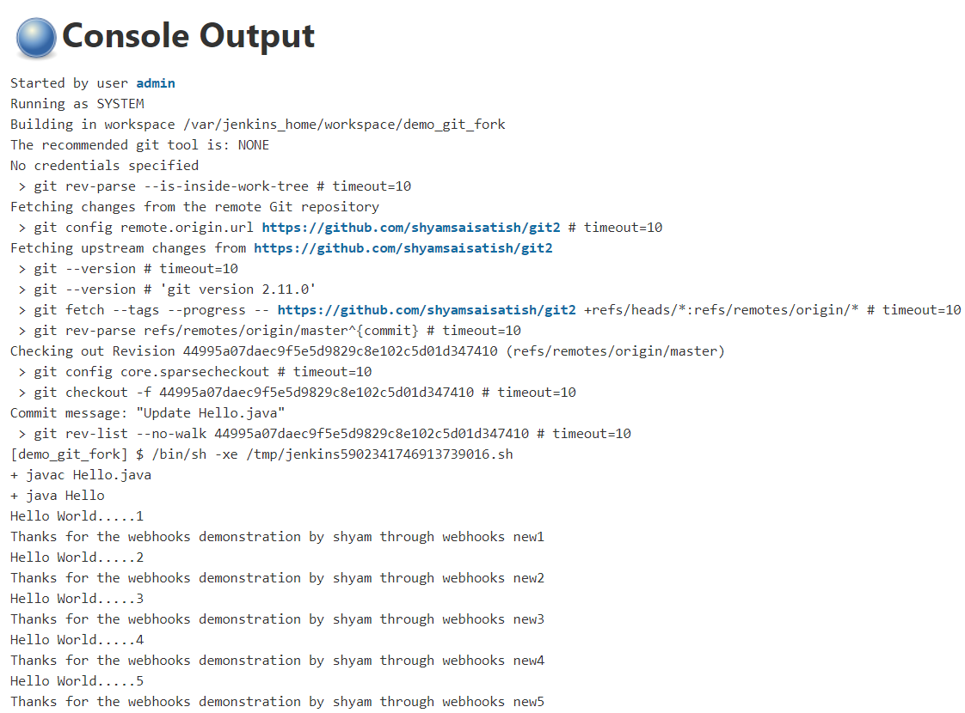

1. Apply web hooks for the forked repository

* Open github and open the required repository
* Open settings tab of the repository and in payload give our Jenkins url along with the extension /github-webhook/ .
* Save it and open jenkins.
* In project configuration add github url and select webhook gitSCM pooling.
* Hence for every change made in git repository automatically build is done.

